**ANUDIP POWER BI WORK**

**1.) PART-1:**

**1.)**

**2.)**

**3.)**

**a-REPRESENT the data,including total count of account numbers against the country,in a tabular format.**

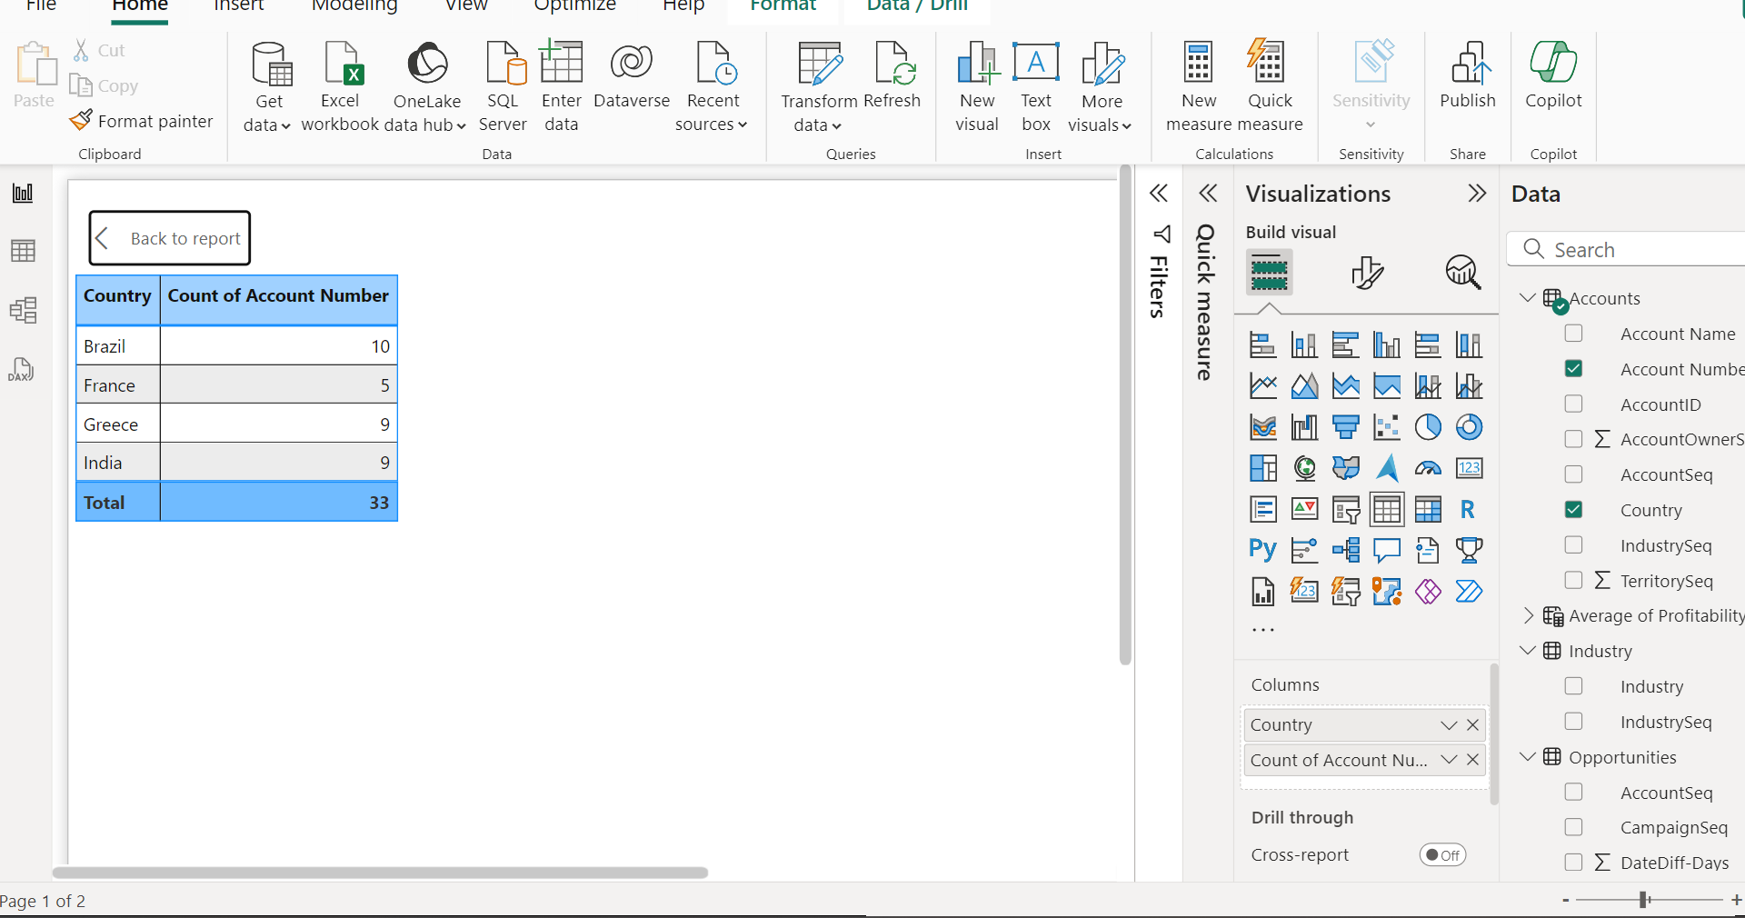

**b-Insert another table and represent the data country wise Account name.**

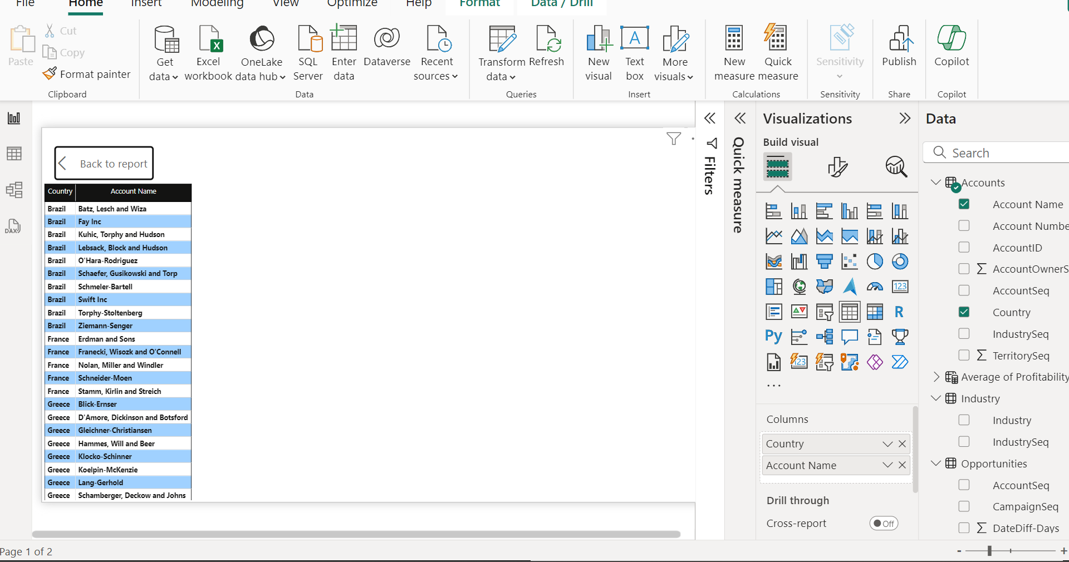

**c-Insert a slicer from the visualization section and add a country-wise filter.**

**d-Represent the data of India,Brazil,Greece and France together.**

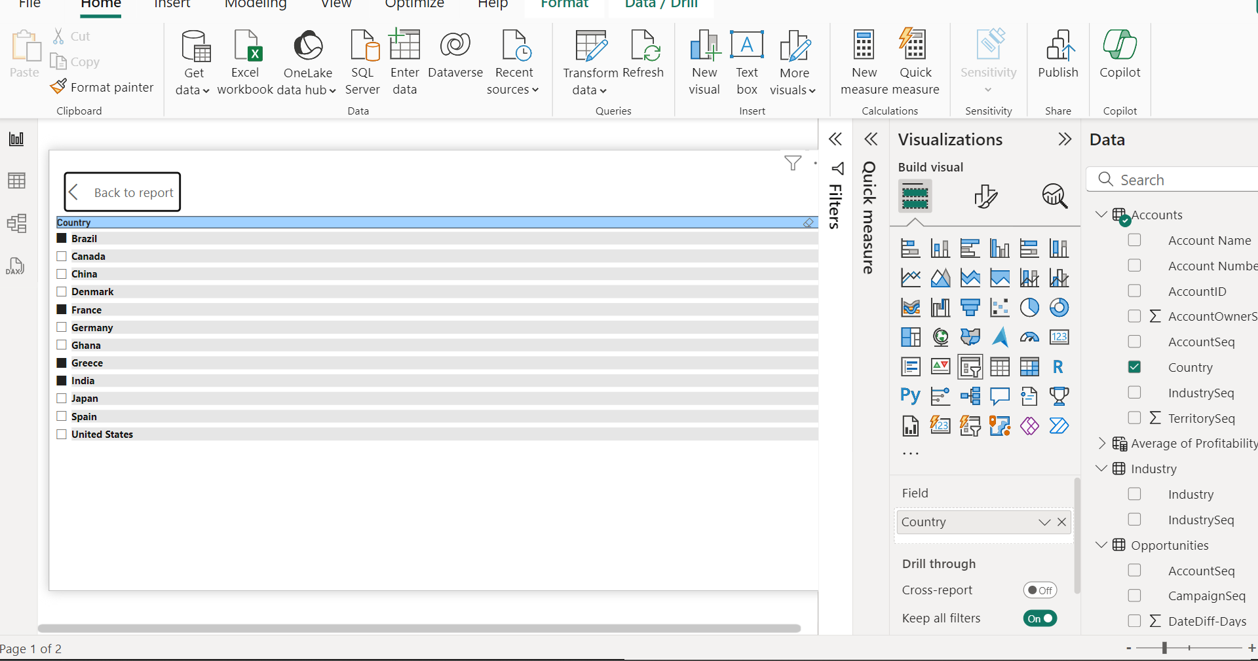

**PART-1 WORK**

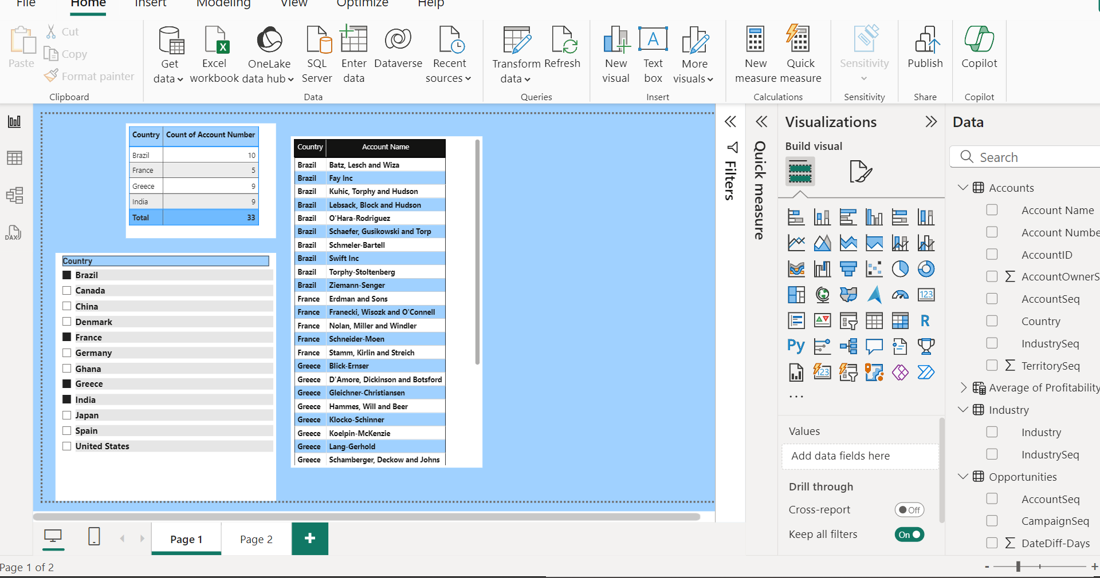

**PART-2**

**1.Add a page for Part 2 work containing Industry,account and opportunity file.**

**2.Represent the data**

**a-Country wise and Average Profitability margin**

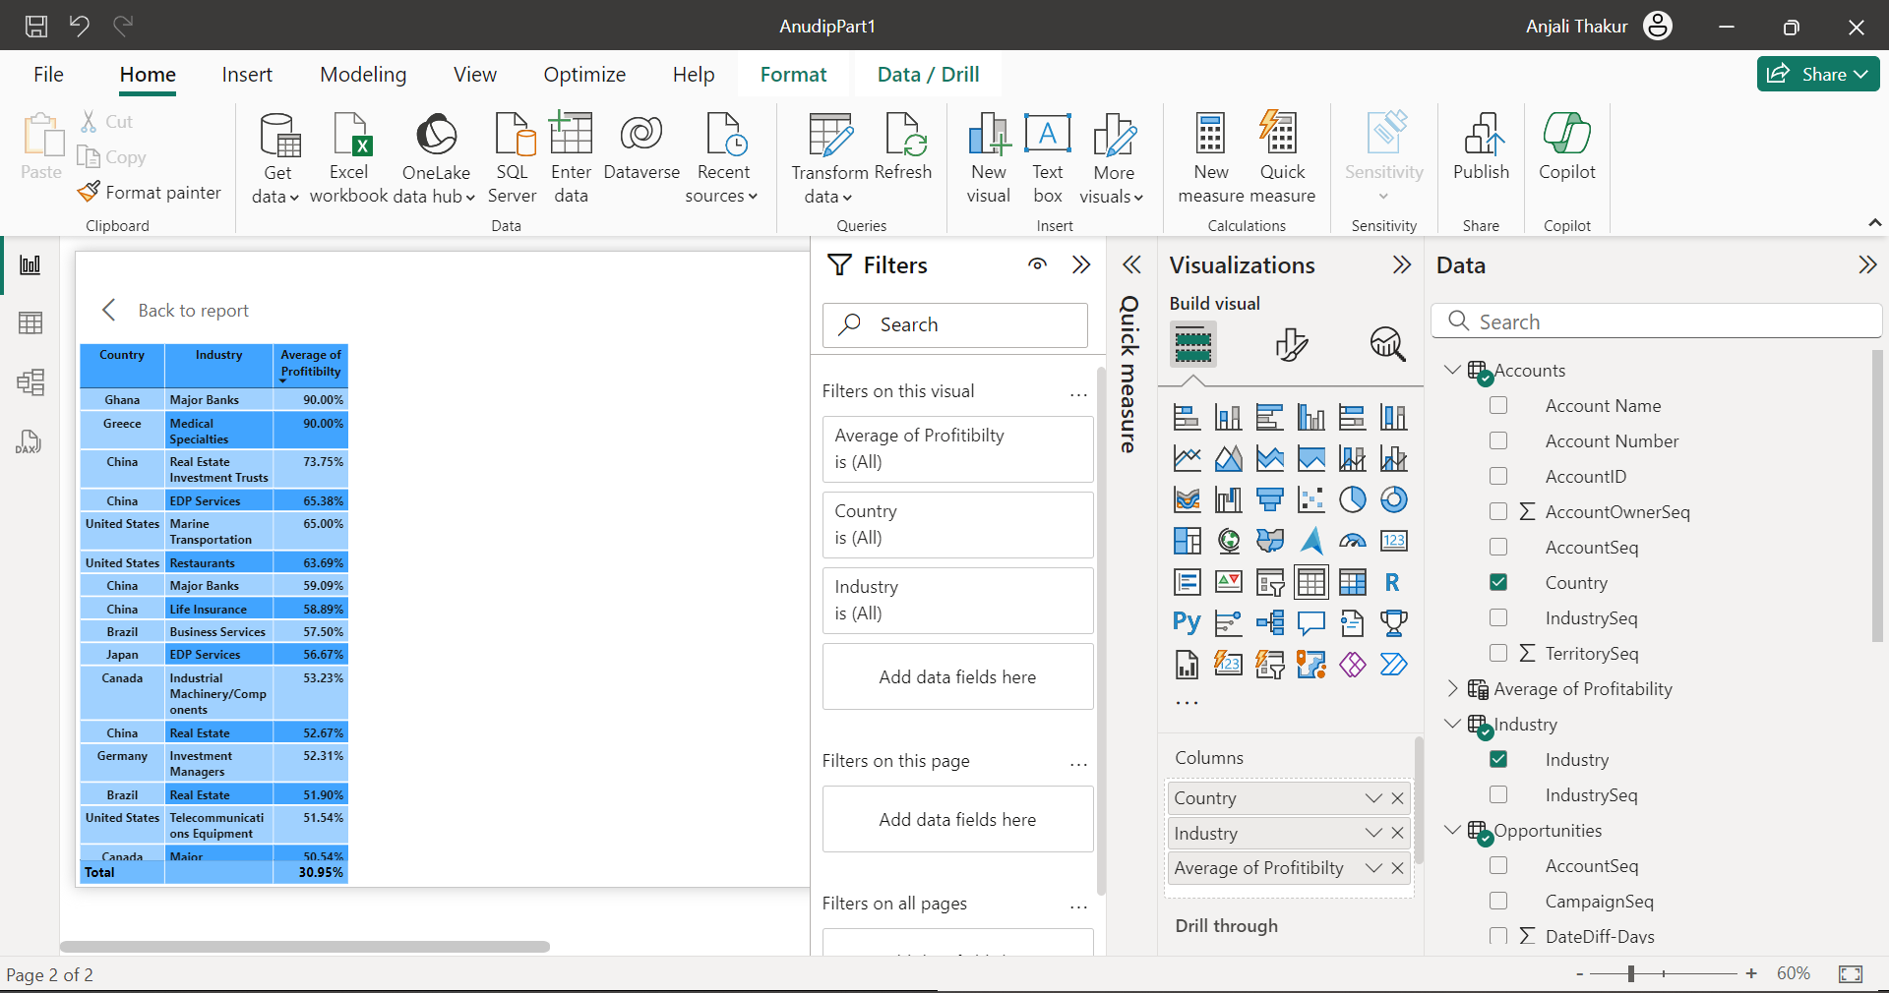

**b-Add a separate filter so that country-wise industry and profitability margins**

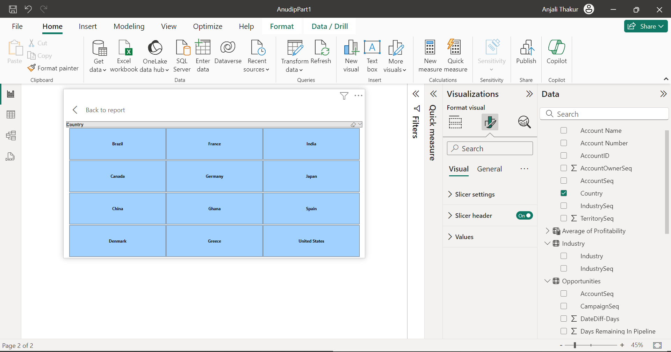

**3.Represent the pie chart**

**a-Industry wise Profitability Percentage**

**b-The data should be visualized in single or multiple country-wise.**

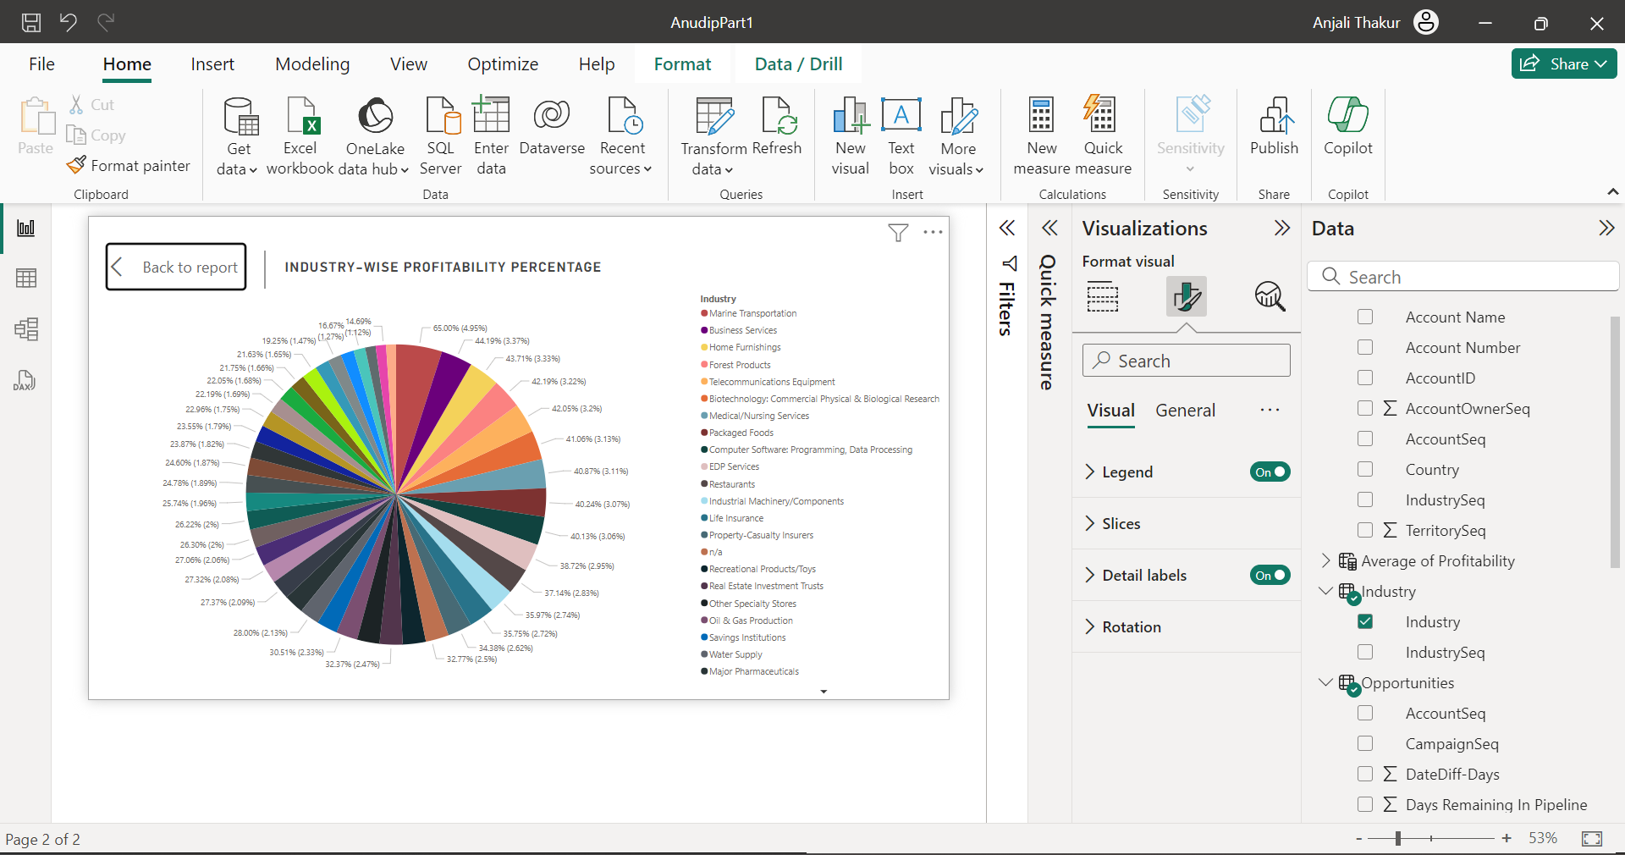

**4.Present the data that shows industry wise profitability trends in line and stacked column chart**

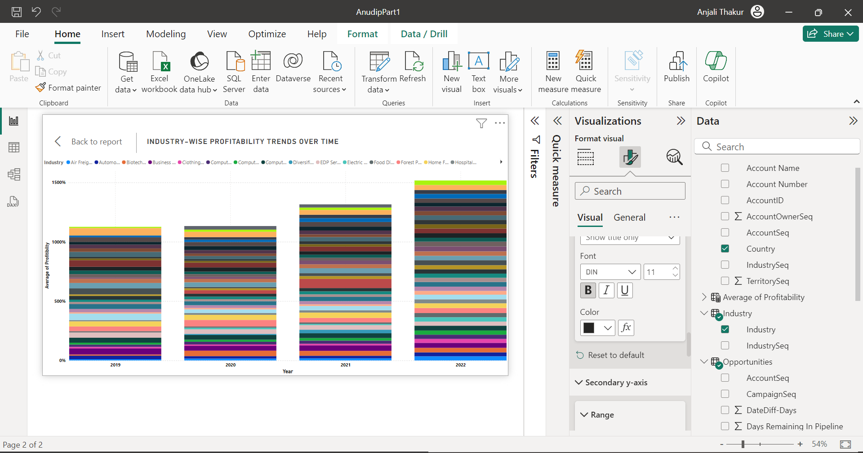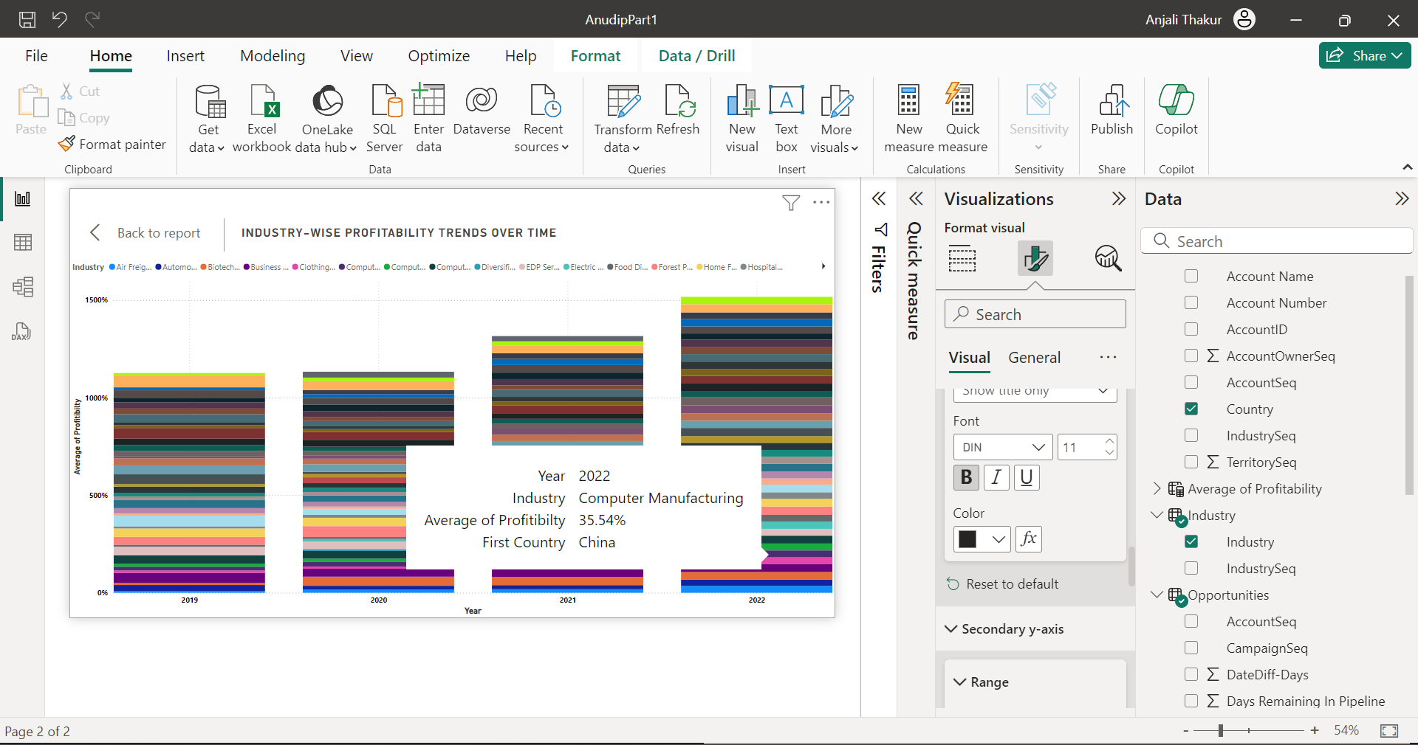

**5. Present the data that shows industry wise Priftability trends taling the map chart.**

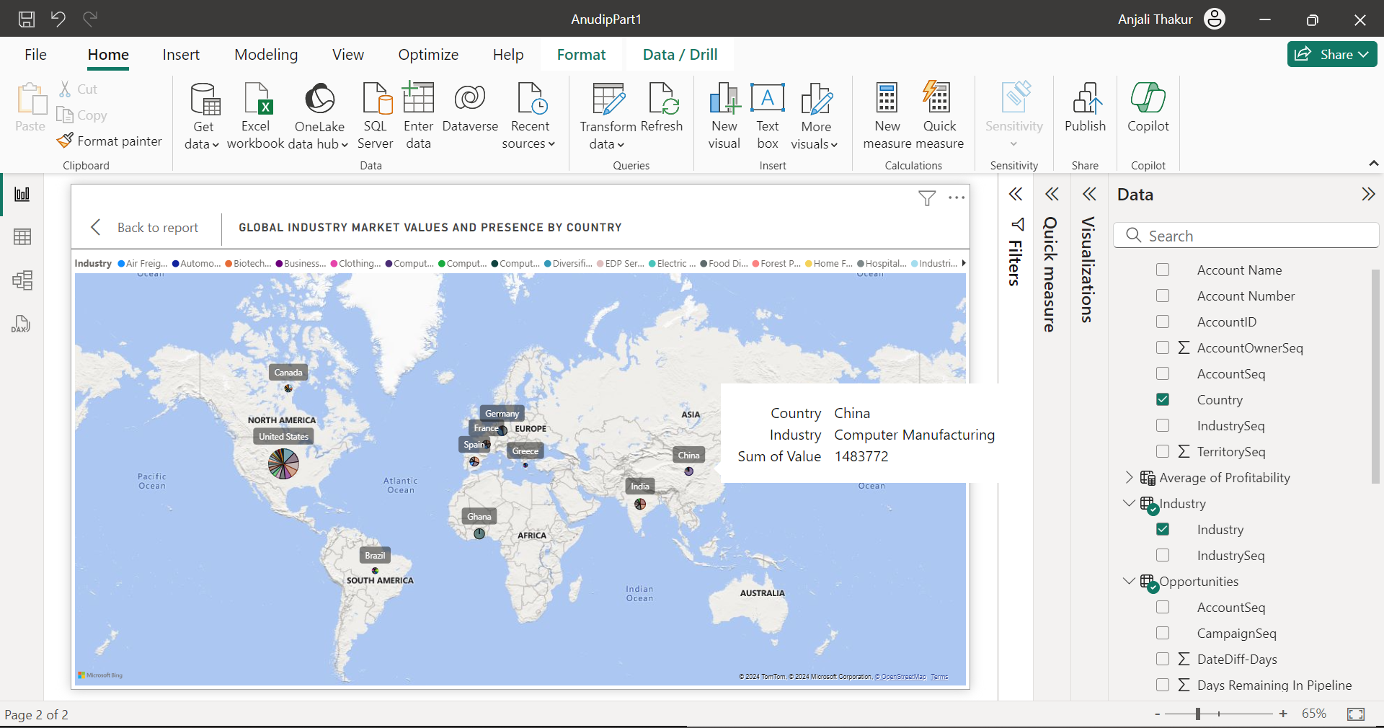

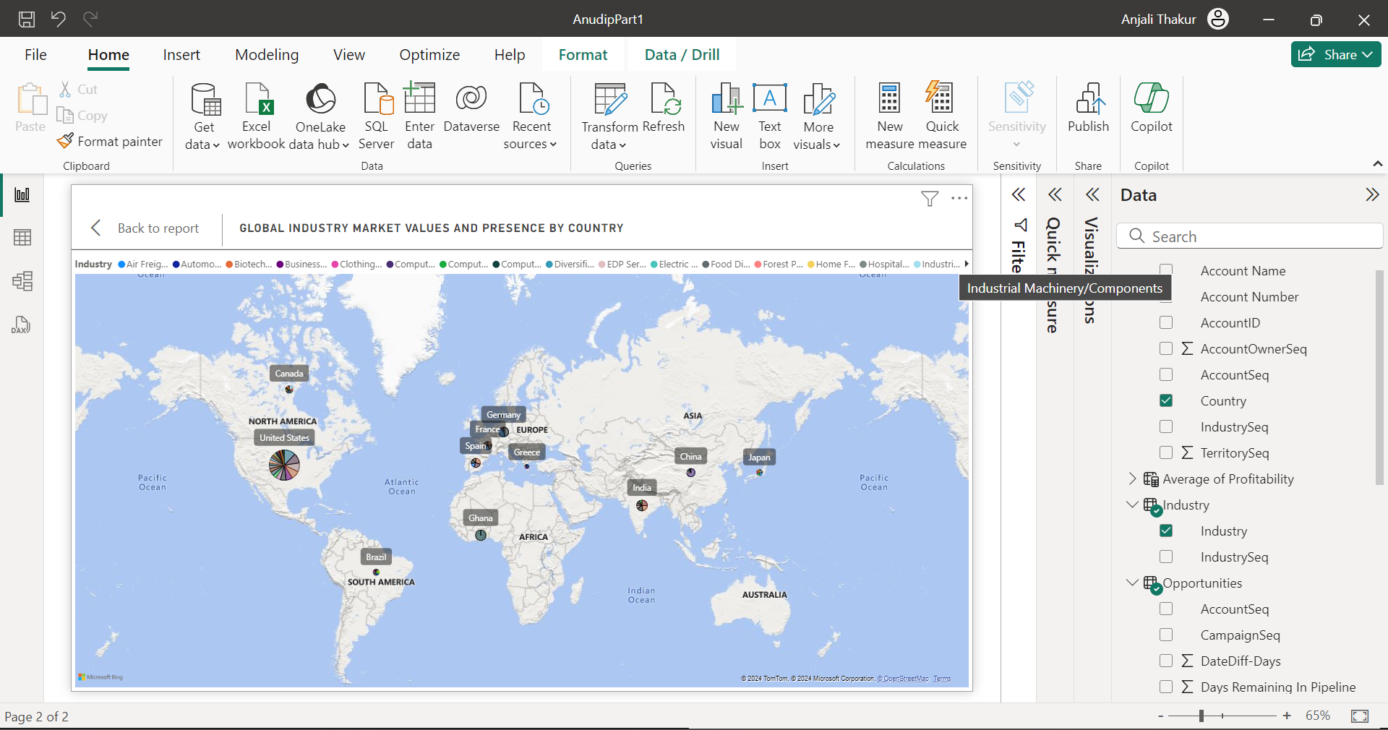

**Part-2-Works**

